

BASIC INFORMATION

Anthropological Literature:
Describes articles and essays on anthropology and archaeology, including art history, demography,
economics, psychology, and religious studies.

Dates Covered: Print Counterpart:
1984 to the present. Updated quarterly Lockwood Reference (Index Area) (Non-Circulating)
CALL NUMBER:
Ref Z 5112.A6 v. 11 (1989)- v.20 (1998)

BASIC SEARCH SCREEN
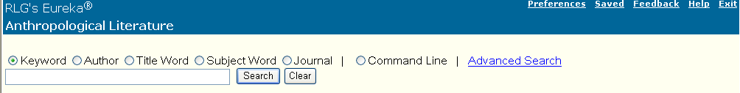
If you would like additional help click on the help button. It will also provide information on the Advanced search option.

Keyword searches for distinctive words that appear in almost all parts of the record.

Use Author when you know an author's last name, entering the person's last name then first name or initial, separated by a comma.

Use Title Word to search for journal articles, journal names, book titles, book chapters, or newspaper articles. Title Word locates distinctive words in titles.

Use Subject Word to find distinctive word(s) within one subject heading.

Use Journal when you know the first words of a journal title.

RESULTS SCREEN

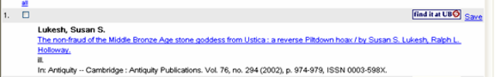
Author(s) of the article

Title of the article

Name of Journal City of Publication Publisher Volume, Issue (Date) Article page numbers
ISSN of Journal
Click on the find it at UB link and it will take you to an electronic full text article if one exists. If UB does not have the article in electronic form, contact a librarian for assistance in searching for a hardcopy or getting it through Interlibrary Loan.

